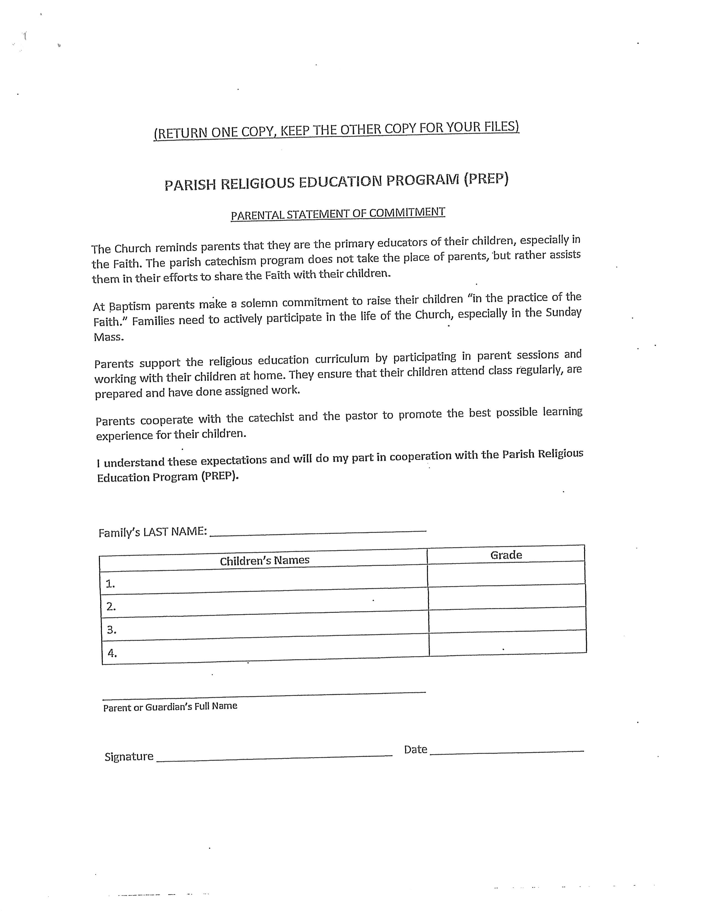

OUR LADY OF THE ASSUMPTION PARISH
CATECHISM PREP PROGRAM 2023-2024 Individual Registration Form

Please review your information and correct where applicable in the spaces provided. ALL FIELDS ARE REQUIRED.

Surname: First Name: Gender:
-

Date of Birth: School Attending (2023-2024): Grade (2023-2024):

-
Circle Selected Time
Kinder 4PM 6PM --
Gr 1 4PM 6PM --
Gr 2 4PM 6PM --
Gr 3 4PM 6PM --
Gr 4 4PM 6PM --
Gr 5 4PM 6PM 7:15PM
Gr 6 4PM 6PM 7:15PM
Gr 7 -- 7:15PM
2SP & 5SP 6PM ONLY
Sacraments Parish where received: Date:

Baptism

1st Confession

1st Communion
Documents included with this registration(CIRCLE): Baptismal Cert. / 1st Comm. Cert. / Conf. Cert.
If applicable, Last Grade of PREP completed or finishing: _____
NOTE: Other than Grade 7, Sp.2 & Sp5, student can change to other available time due to family schedule confrlict during the year.
Registration to Grade: _ ___

Family Information

Mother’s Full Name: Maiden Name: Religion:

-

Father’s Full Name: Religion:

-

Address City Postal Code
-

Home Phone: Cell Phone(s):

Day-time Phone Number(s): Family e-mail (Important!):

-

Emergency Contact (Other than parents): Emergency Contact Phone (Other than parents):

-
Grades 2 & 7
Sacramental Years

Gown Rental: $30

Circle applicable fees – ONE FORM PER CHILD

Course Fees Before May.31st Jun.1st-Jul 4th– From Jul 5th
1st Child $80 $100 $125
2nd Child $20 $20 $20
LOON LAKE Confirmation Retreat (Grade 7)
Payable in full or 2 Instalments

Grade 6: $100.00
Grade 7: $100.00

3rd Child $20 $20 $20
If 2nd or 3rd child, indicate name of 1st sibling: _______________

Active Parishioner min 2 Months
Envelope # (required) _________
OR
Non-Parishioner
or Non Active Fee: $20 min=

OFFICE USE ONLY: TOTAL FOR THIS CHILD: $___________ Paid: $___________ Balance: $__________

Date: _______________ Cheque Number:________ Issued by: _______________ Received by: ___________

